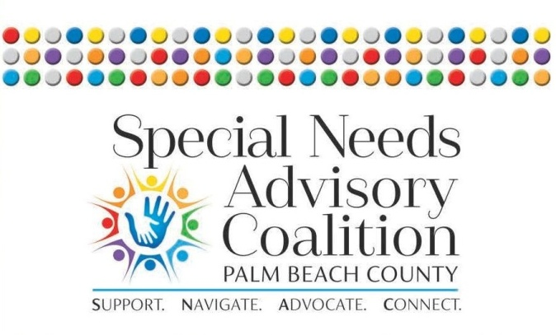

The Special Needs Advisory Coalition (SNAC) of Palm Beach County is excited to announce our inaugural Community Inclusion Awards. A celebration of individuals, nonprofit and for-profit organizations who are committed to serving and supporting the special needs community! Awards for all categories will be given on Wednesday, October 10, 2018, at a special ceremony and luncheon beginning at 11:30 am at the Boca West Country Club. We can't wait to celebrate the actions and impact being made in Palm Beach County by local leaders, service providers and advocates.

SNAC is now accepting nominations in twelve (12) different categories:

- Direct Service Professional of the Year
- Respite Care Companion of the Year
- Supportive Housing Provider of the Year
- Self-Advocate of the Year
- Employer of the Year
- Employee of the Year
- Teacher/Educator of the Year
- Healthcare Provider of the Year
- Post Secondary Program of the Year
- Innovation & Collaboration of the Year
- Volunteer of the Year
- Champion of Inclusion Award

Individuals, nonprofit and for-profit organizations are encouraged to submit an application in one or more categories. An organization/individual will only be named a finalist in one category.

Three finalists will be selected in each category by a panel of judges. Finalists will be revealed at the Announcement Party on September 5, 2018. All of the finalists will receive publicity via press releases and social media activity. Applicants who are not finalists will be eligible for the Community Choice Award. Community Choice Award recipient will be determined by on-line voting.

Criteria & Instructions

Nominations must be received by 5:00 pm on July 30, 2018. Please send completed nomination form to: tony@misternonprofitconsultancy.com

All nominees must meet the following criteria:

- Individuals/organizations must regularly advocate, deliver services and support to the special needs community in Palm Beach County. Individuals/organizations may self-nominate or be nominated by others.
- Organizations/Individuals may be nominated in more than one category.
- An organization may only be a finalist in one category (the category in which the organization scored the highest).

Application instructions and required attachments

- The cover page and all questions for the appropriate award category must be completed in full.
- Please answer each question fully, but succinctly.
- The answer portion of the application may not exceed 2 pages and no less than an 11pt font.
- Really tell the story and share the passion of why your nominee/organization should be an honoree.
- Our panel of judges will score nominations based solely on information provided in the nomination application package.
- Please send your logo with your application in 300dpi jpeg format.
- If you have any questions, please contact Tony Beall, of Mister Nonprofit Consultancy, at 754.281.8728 or tony@misternonprofitconsultancy.com.

Self-Advocate of the Year
This award honors an individual/organization that embodies excellence, integrity and passion in providing support/services to the Palm Beach County special needs community. The nominee will demonstrate self-advocacy as knowing when and how to approach others to negotiate desired goals, build mutual understanding and trust, and achieve fulfillment.

Nominee Information

Nominee Name:

Name of Organization/Company (If applicable):

Address:

City/State/ Zip:

Website:

Nominee Email:

Nominee Phone:

Nominator Information
Name:

Title:

Name of Organization/Company (If applicable):

Phone:

Email:

Relationship to Nominee:
Please answer each question using 11 point font. Please do not exceed 2 pages.

- How do you demonstrate the ability to advocate for an improvement that benefits not only the self, but the special needs community-at-large?

- How do you practice advocacy that not only brings awareness to special needs, but also introduces the concept of acceptance and the belief in autonomy?

- How do you interact with a variety of individuals and groups associated with special needs? Are you able to influence said groups to advocate for change that continues to support the ideas of awareness, acceptance, and autonomy for individuals with special needs?

- Provide examples of how you are foreseeing opportunities to help through the efforts of self-advocacy and advocacy?

- How do you advocate for inclusive opportunities for individuals with special needs?

